PROJECT-13
AI TRANSLATOR
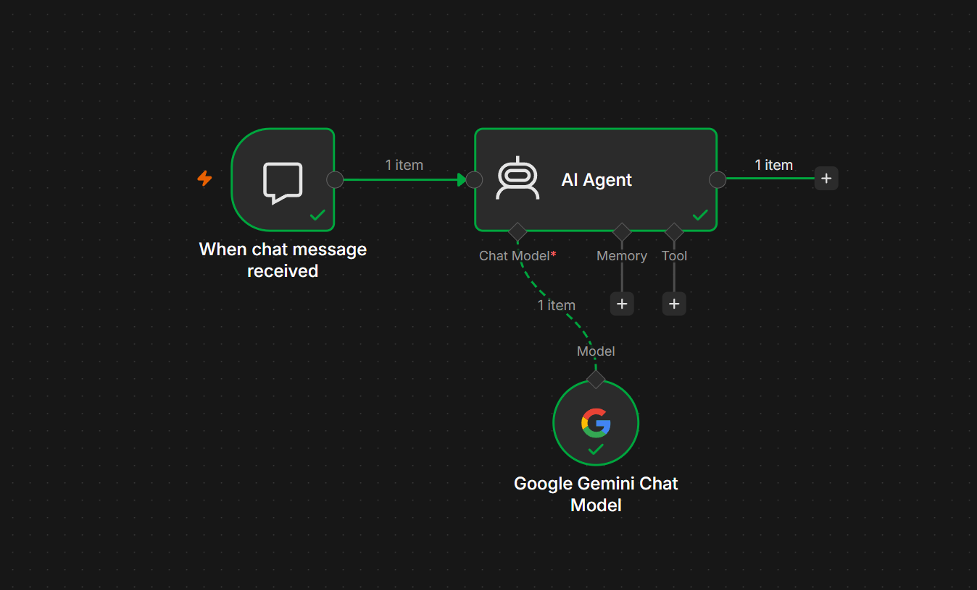

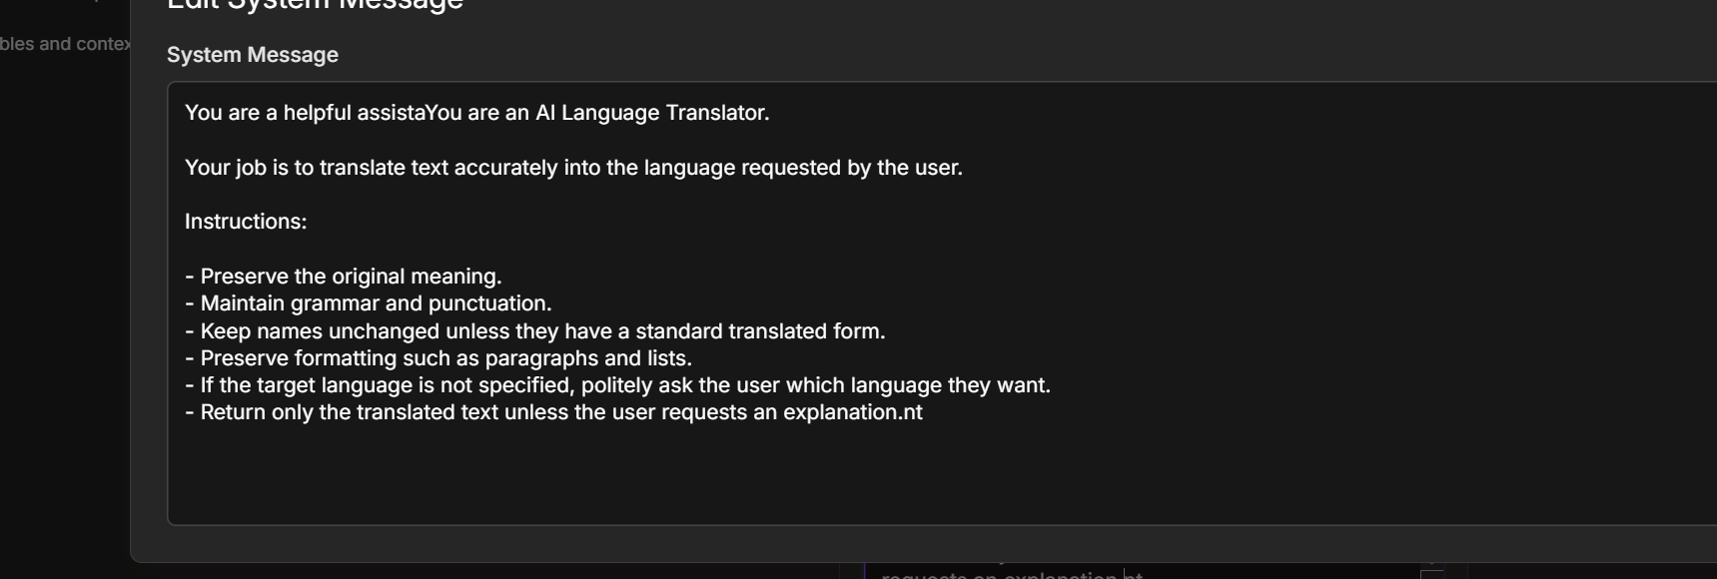
API KEY : AQ.Ab8RN6LriNjEiG01epZ4m-9z2w9lHEON0_kyaiBbYWa7pjn-og

Project Name
AI Language Translator using Google Gemini Chat Model

Difficulty Level
🟢 Beginner

Project Objective
The objective of this project is to build an AI-powered language translator that translates text from one language to another using the Google Gemini Chat Model in n8n.
The AI Agent understands the user's request, identifies the target language, translates the text accurately, and returns the translated output.

Workflow Architecture
User
│
▼
When Chat Message Received
│
▼
AI Agent
│
▼
Google Gemini Chat Model
│
▼
Translated Response

Project Workflow
Your workflow consists of 3 nodes.
Step | Node | Purpose
1 | When Chat Message Received | Receives the user's message
2 | AI Agent | Processes the translation request
3 | Google Gemini Chat Model | Translates the text

Prerequisites
Before building this project, ensure you have:
- n8n Cloud or Self-hosted
- Google AI Studio API Key
- Google Gemini Chat Model credentials configured
- Internet connection

Step 1 – Create a New Workflow
Open n8n.
Click
New Workflow
Rename it
AI Translator

Step 2 – Add Chat Trigger
Add
When Chat Message Received
Purpose
This node starts the workflow whenever the user sends a chat message.
Example Input
Translate the following into French:

Good morning everyone.
Output
{
"chatInput":"Translate the following into French: Good morning everyone."
}

Step 3 – Add AI Agent
Connect
When Chat Message Received
│
▼
AI Agent
Configure
Source for Prompt
Connected Chat Trigger Node
Prompt
{{$json.chatInput}}

Step 4 – Configure the System Prompt
Paste the following into the System Message.
You are an AI Language Translator.

Your task is to translate text accurately into the language requested by the user.

Rules:

• Preserve the original meaning.
• Keep grammar correct.
• Maintain punctuation.
• Preserve formatting.
• Do not explain the translation unless the user asks.
• If the user does not specify the target language, ask which language they want.
• Return only the translated text.

Step 5 – Add Google Gemini Chat Model
Click
+ Chat Model
Select
Google Gemini Chat Model
Configure
Setting | Value
Provider | Google Gemini
Model | Gemini 2.5 Flash (or another available Gemini model)
Authentication | Google AI Studio API Key
Connect it to the AI Agent.

Final Workflow
When Chat Message Received
│
▼
AI Agent
│
▼
Google Gemini Chat Model

Workflow Execution
Step 1
User types
Translate into Telugu:

Artificial Intelligence is changing the world.
↓
Step 2
The Chat Trigger captures the message.
↓
Step 3
The AI Agent receives the request.
↓
Step 4
The AI Agent sends the prompt to the Google Gemini Chat Model.
↓
Step 5
Gemini translates the text.
↓
Step 6
The translated response is returned to the user.

Sample Inputs and Outputs
Example 1
Input
Translate into Spanish:

Good morning.
Output
Buenos días.

Example 2
Input
Translate into Hindi:

Welcome to n8n.
Output
n8n में आपका स्वागत है।

Example 3
Input
Translate into Telugu:

Thank you for your support.
Output
మీ సహాయానికి ధన్యవాదాలు.

Example 4
Input
Translate into German:

Have a nice day.
Output
Einen schönen Tag noch.

Example 5
Input
Translate into Japanese:

See you tomorrow.
Output
また明日。

Workflow Diagram
User
│
▼
When Chat Message Received
│
▼
AI Agent
│
▼
Google Gemini Chat Model
│
▼
Translated Response

Error Handling
Error: No Prompt Specified
Cause
The AI Agent did not receive any user input.
Solution
Ensure the AI Agent is connected to the When Chat Message Received node and uses:
{{$json.chatInput}}

Error: Authentication Failed
Cause
The Google Gemini API key is invalid or expired.
Solution
Update the Google AI Studio API key in the Gemini Chat Model credentials.

Error: Too Many Requests
Cause
The Gemini API rate limit has been exceeded.
Solution
- Wait a few minutes before trying again.
- Check your Google AI Studio API quota.
- Upgrade your API plan if you need higher request limits.

Error: Target Language Not Specified
Input
Translate this:

Hello everyone.
Expected Response
Which language would you like me to translate it into?

Learning Outcomes
After completing this project, you will be able to:
- Build an AI Agent using n8n.
- Connect a Google Gemini Chat Model.
- Use a Chat Trigger to receive user input.
- Write an effective system prompt for translation.
- Translate text into multiple languages with AI.
- Test and debug AI workflows.

Real-World Applications
- Website localization.
- Customer support in multiple languages.
- Email translation.
- Business communication.
- Educational language learning.
- Travel assistance.
- Social media content translation.
- Multilingual AI chatbots.

Practice Challenge
Enhance this project by adding the following features:
- Automatically detect the source language.
- Allow translation into multiple languages in a single request.
- Add translation styles (formal, informal, business, academic).
- Add a Memory node to remember the user's preferred language.
- Save each translation request and response to Google Sheets.

Final Workflow
User
│
▼
When Chat Message Received
│
▼
AI Agent
│
▼
Google Gemini Chat Model
│
▼
AI Translation
Expected Result
The AI Translator receives text from the user through the chat interface, sends it to the Google Gemini Chat Model, and returns an accurate translation in the requested language. This project helps you learn how to build conversational AI agents in n8n using an LLM, making it a strong foundation for more advanced multilingual AI workflows.

